All the Paths: Mirror, Lens, and Grating
  - Prologue 3 of Quantum, Actually, Volume 2: A QED Course
Lothar J. Musiol

Light does not choose one path. Every path gets an arrow; most of them cancel. What survives looks like "angle in equals angle out", like a lens focusing, like the colours on a CD

First edition, 2026

How to use this prologue
So far, each event had one or two ways to happen. Now there will be thousands, and you will see that the rule from Prologue 1 still works without any change: one arrow per way, add them all, square. The new skill is to see which arrows matter. Squared paper helps. Expect three hours.

Learning objectives
- Explain why light reflecting from a mirror must be treated as reflecting from every part of the mirror.
- Use the time taken along each path to see which arrows line up and which cancel.
- Recover the law of reflection and the idea of "least time" from the arrows.
- Explain a diffraction grating by removing the parts of a mirror whose arrows point the wrong way.
- Explain how a lens focuses light by making every path take the same time.
- Explain why squeezing light through a narrow gap makes it spread out.

Words you will need
Word | What it means here
path | One possible route from the source to the detector
travel time | How long light takes along a path; sets how far the stopwatch turns
least time | The path whose travel time is shortest (or, more generally, does not change for nearby paths)
grating | A surface with many fine, evenly spaced lines
focus | A point where light from a source is brought together again

1 A mirror, done honestly
A lamp at S and a detector at P sit above a flat mirror, with a screen between them so that no light goes straight across. School physics says light hits the mirror at one point, the one where the angle in equals the angle out, and bounces to P.
The arrow rule says something more radical: light can reflect from any point on the mirror. Each point gives a different path from S to P, and every path gets an arrow. To find the probability that P clicks, add the arrows for all the paths, then square.
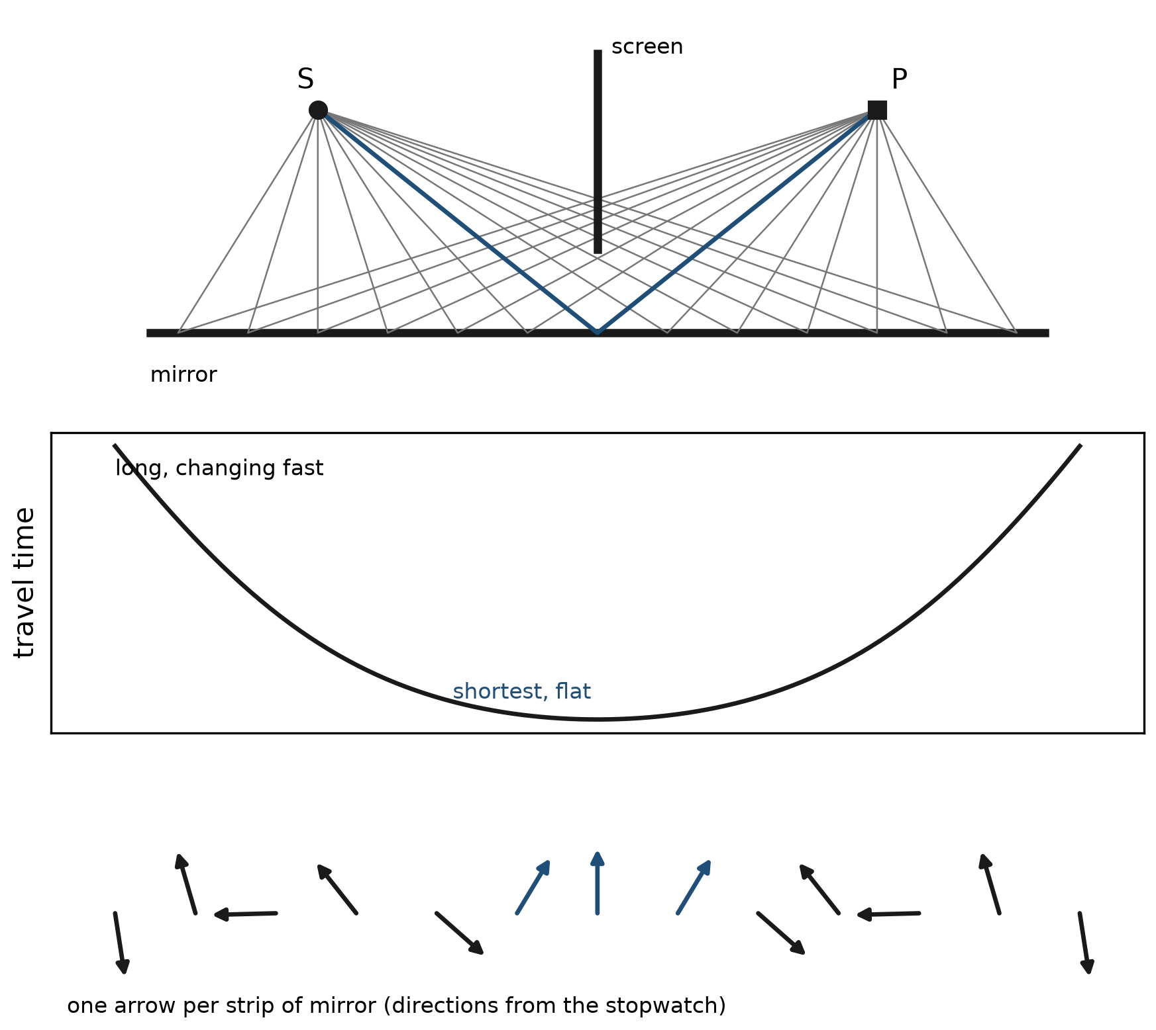
Figure P3.1. Top: some of the paths from S to P via different points on the mirror. Middle: the travel time for each path; it is smallest, and nearly flat, at the middle. Bottom: the arrows for the paths, one per mirror strip. The arrows from the middle point the same way; the arrows from the ends spin round.
Look at the middle graph. Paths that reflect near the ends of the mirror are long, and their lengths change quickly from one strip to the next. Paths near the middle are shortest, and — this is the important part — their lengths barely change from one strip to the next, because the bottom of a curve is flat.
Now look at the arrows. All arrows have about the same length (each strip of mirror reflects about equally). Their directions come from the stopwatch, that is, from the travel time. Near the ends, neighbouring paths differ in time a lot, so their arrows point every which way and cancel in little loops. Near the middle, neighbouring paths have almost the same time, so their arrows point almost the same way and add up.
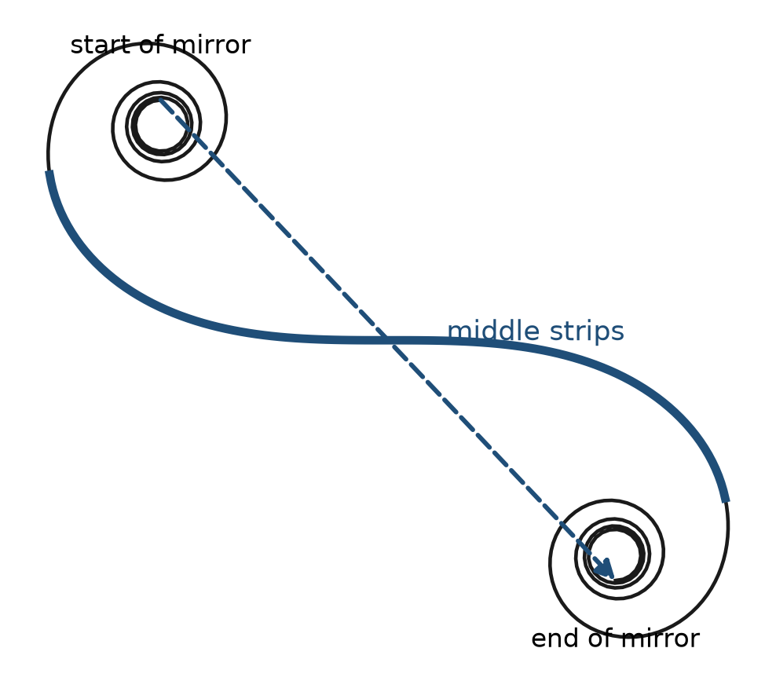
Figure P3.2. Adding all the mirror arrows tip to tail. The ends of the mirror make tight curls that go nowhere; the middle makes the long straight stretch. The final arrow (blue) is almost entirely the middle's contribution.
So the final arrow comes almost entirely from the middle of the mirror, where the angle in equals the angle out. The law of reflection is not wrong. It is what is left over after almost all the arrows have cancelled.
Try it now 1
You cut off the left quarter of the mirror. Does the probability that P clicks change much? What if instead you cut out a strip right in the middle?

2 Least time
The path that survives is the one where the travel time is least. More precisely, it is the one where the travel time does not change when you move the path a little. That is what makes neighbouring arrows agree. People had noticed long before quantum mechanics that light seems to "choose" the quickest path (Pierre de Fermat stated it in the 1600s). The arrows show why: it is not a choice. Light tries every path, and only near the quickest one do the arrows agree.
The same idea gives refraction. When light goes from air into water, it is slower in the water. The quickest route from a point in the air to a point under the water is not a straight line: it is a bent line that spends a little less of its length in the slow water. A lifeguard running on sand and then swimming does the same. The arrows of all the paths near that quickest bent path agree; the others cancel. That is why a straw in a glass of water looks bent.
The same cancellation works for things with mass. For a thrown ball, the quantity whose arrow turns along each path is not the travel time but a quantity called the action, and the path that survives is the one whose action does not change for nearby paths: the path Newton would have predicted. Least time is the special case that applies to light. In neither case does anything decide in advance. Every path contributes; only after the cancellations does one path stand out, as if it had been chosen on purpose. Lessons 5 and 80 make this exact.
Try it now 2
In Figure P3.1, would the arrows from the middle of the mirror still line up if the mirror were tilted so that the shortest path hit it near one end? Where would the final arrow come from then?

3 A grating: keeping only the arrows you want
Go back to the mirror and look at a part near one end, where the arrows spin round and cancel. Suppose you could scrape away the strips whose arrows point, say, to the left, and keep only those whose arrows point to the right. The remaining arrows no longer cancel. They add up — and P clicks, even though P is not where "angle in equals angle out" says it should be.
That is exactly what a diffraction grating is: a surface with fine lines, evenly spaced, so that only every other zone of the mirror reflects. Light reflects strongly in directions where the kept arrows line up.
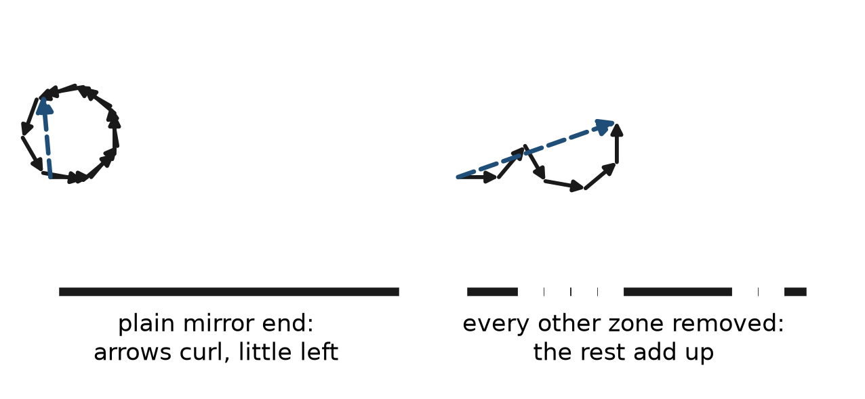
Figure P3.3. Left: arrows from the end of a plain mirror cancel. Right: the same part of the mirror with every other zone removed (a grating). The remaining arrows all point roughly the same way and add up to a sizeable final arrow.
The spacing that makes the arrows line up depends on how fast the stopwatch turns — on the colour. So a grating sends red light to one angle and blue to another. The shimmering colours of a compact disc or a DVD are exactly this: the tracks are a grating. So are the colours of some beetles and feathers, whose surfaces carry very fine, regular ridges.
Try it now 3
Why does a grating spread white light into a rainbow, while a plain mirror does not?

4 A lens: making every path equally quick
Now ask the opposite question. Instead of throwing arrows away, could we make all the arrows for paths from S to P point the same way? Then nothing would cancel, and P would get a great deal of light.
The straight path from S to P is the quickest. Paths that go out at an angle are longer and take more time. To make them all take the same time, slow down the short paths and leave the long ones alone. Glass slows light down. So put more glass where the paths are short — in the middle — and less glass where the paths are long — at the edges. That shape is a lens.
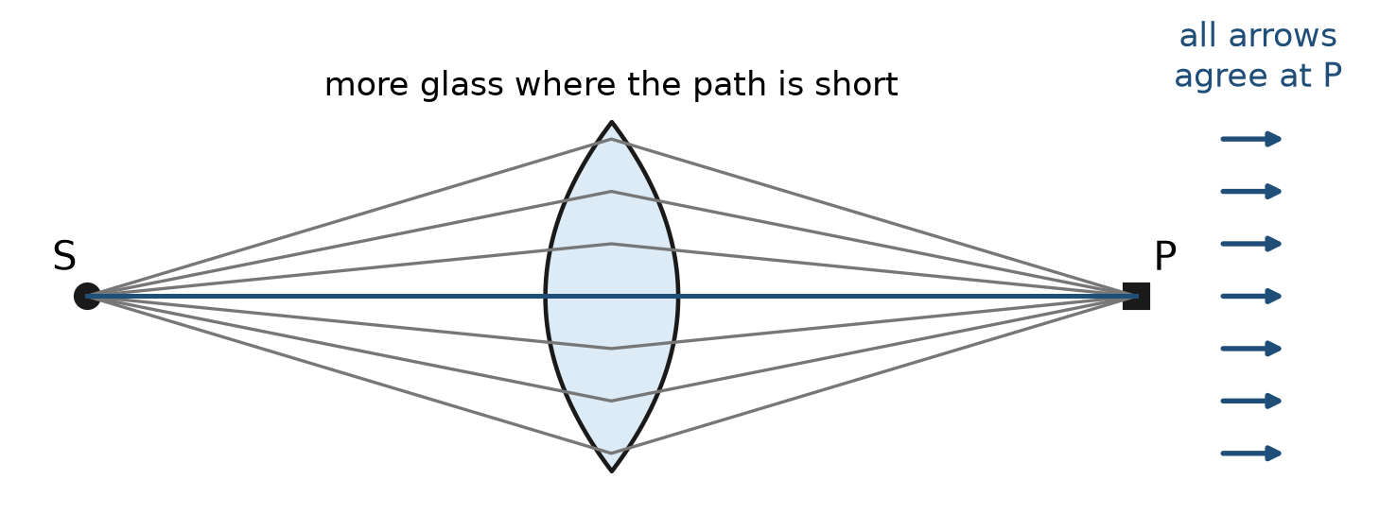
Figure P3.4. A lens adds just enough glass to each path to make every path from S to P take the same time. All the arrows then point the same way and add up: light is focused on P. For a point beside P, the times differ again and the arrows cancel.
At the focus P, every arrow points the same way: a large final arrow and a bright spot. For a point Q a little to one side of P, the paths are no longer equally quick; the arrows spread out and cancel; Q stays dark. A lens is a device for lining up arrows at one point.

5 Squeezing light makes it spread
Last, a puzzle you can check with a laser pointer and two razor blades. Light from S goes through a gap to a screen. With a wide gap, light goes straight: a point Q off to the side gets nothing. Narrow the gap, and something surprising happens: light starts to arrive at Q.
The arrows explain it. With a wide gap there are many paths to Q, and their times differ a lot from one side of the gap to the other: the arrows spin round and cancel. With a very narrow gap there are only a few paths to Q, and their times are almost the same, so there is not enough spread to make them cancel. They add up to something, and Q receives light. The narrower the gap, the wider the spread. This is diffraction, and it is the same reason why you cannot make a beam of light infinitely thin.
Try it now 4
Two gaps of the same width: one 1 mm wide, one 0.01 mm wide. Through which does a laser beam spread more on a far screen?

6 A path is not a track
The language of this prologue can mislead. "Light goes by all paths" does not mean that a photon is smeared across the mirror like paint, or that it splits into a thousand tiny photons. A detector still clicks once, for a whole photon. What every path contributes is an arrow — a piece of the calculation of the probability. The single straight line that light "really" follows in a school drawing is simply the region of paths where the arrows stop cancelling. It was never a rail the photon ran along. Electrons, it will turn out, behave in exactly the same way (Prologue 5).

Connections to QED
Idea in this prologue | Where it becomes exact
Every path gets an arrow | Lesson 9 (Huygens–Fresnel as a sum over paths) and Lesson 80 (the path integral)
Arrows agree near least time | Stationary phase; the classical limit of the path integral (Lessons 5 and 80)
Grating and lens | Lesson 9's diffraction and Fermat's principle
Narrow gap spreads light | Fourier transforms and the uncertainty relation (Lessons 2 and 13)

Summary
- Light reflecting from a mirror has paths through every point of the mirror; each path has an arrow.
- Where the travel time changes little from path to path, the arrows agree and add; elsewhere they cancel.
- This produces the law of reflection, least time and refraction.
- A grating removes the arrows that would cancel; a lens makes every path equally quick so that all arrows agree at the focus.
- A narrow gap leaves too few paths to cancel, so light spreads.

Exercises
No | Problem
1 | Core. In Figure P3.1, which part of the mirror contributes most of the final arrow, and why?
2 | Core. Explain in your own words why the ends of the mirror contribute almost nothing even though light really can reflect there.
3 | Core. Why does a lens have to be thicker in the middle than at the edges to focus light?
4 | Core. A grating sends red light to a larger angle than blue light. Which colour's stopwatch turns faster, and is that consistent with Prologue 1?
5 | Core. What is the difference between "light goes by every path" and "the photon is split into many pieces"?
6 | Extension. Ten arrows of length 0.1 point exactly the same way; ten more of length 0.1 make a complete circle when placed tip to tail. What is the final probability?
7 | Extension. A lifeguard can run 7 m/s on sand and swim 1.5 m/s. Explain qualitatively why the quickest route to a swimmer is a bent line, and connect this to a straw looking bent in water.
8 | Extension. If you painted black stripes on a mirror so that the shortest path hit a black stripe, would the detector at the reflection point go completely dark?
9 | Challenge. A grating's lines are 1.5 micrometres apart. For red light (0.65 micrometres) and blue light (0.45 micrometres), which colour needs the larger angle for the arrows from neighbouring lines to differ by one whole turn?
10 | Challenge. Explain, using arrows, why a lens with a scratch on the edge still focuses well, but a large dirty patch in the middle of a mirror placed at the reflection point still does not stop the reflection completely.

Solutions
Try each exercise on paper before you look. If you are stuck, re-read the section named in the exercise, try again, and only then read the solution below.
1. The middle, around the point where the angle in equals the angle out. There the travel time is smallest and barely changes from strip to strip, so neighbouring arrows point the same way and add.
2. Light does reflect there, and those arrows are just as long. But neighbouring paths at the ends differ in travel time by a lot, so their arrows point in very different directions; added together they curl round and cancel.
3. The straight path through the middle is the shortest and would arrive first. Extra glass in the middle slows it down, so that it takes as long as the longer, slanting paths through the thin edges. With equal times, all the arrows agree at the focus.
4. Blue light's stopwatch turns faster (Prologue 1: 2.25 versus 1.5 million turns per metre). With a faster stopwatch, a smaller extra path is enough to make one extra turn between neighbouring lines, so blue lines up at a smaller angle; red, with the slower stopwatch, needs a larger angle. Consistent.
5. Every path contributes an arrow to the calculation of one probability. The detector still registers one whole photon or nothing. Nothing physical is split.
6. The circle closes, so the ten circling arrows add to zero. The ten aligned arrows make length 1.0. Probability 1.0² = 1. (In a real situation the lengths would be smaller; the point is that a closed curl contributes nothing.)
7. Swimming is slow, so the quickest route spends less distance in the water and more on the sand: it runs along the beach a bit before turning into the water. The path is bent at the water's edge. Light is slower in water than in air, so the quickest path from your eye to the straw's tip is bent at the surface in the same way, and the straw appears to be somewhere it is not.
8. Not completely. The arrows from the middle strips are missing, so the final arrow becomes much smaller, but arrows from the strips on either side do not cancel perfectly; there is also a grating-like contribution from the stripes themselves. The detector gets much less light, not zero.
9. One extra turn needs an extra path of one wavelength between neighbouring lines. The extra path grows with the angle, so the longer wavelength (red, 0.65 μm) needs the larger angle; blue (0.45 μm) lines up at a smaller angle.
10. The edge of a lens carries only a few of the many equally-timed paths, so losing them shortens the final arrow a little; the rest still agree at the focus. The middle of the mirror carries the arrows that do not cancel, so covering it removes most of the final arrow. Uncovered arrows at the boundary of the dirty patch no longer have partners to cancel against, though, so some reflection survives.

Answers to Try it now
1. Cutting off the left quarter barely matters: those arrows were cancelling anyway. Cutting out the middle strip matters a lot: the arrows that add up are gone, and the reflection becomes much weaker.
2. The final arrow still comes from wherever the travel time is flattest, the point where angle in equals angle out. If that point is near one end of the mirror, the final arrow comes from near that end; if it falls off the mirror altogether, little light reaches P.
3. A plain mirror's surviving arrows come from the least-time point, which is the same for every colour. A grating's surviving arrows depend on the line spacing compared with each colour's stopwatch speed, so each colour lines up at its own angle.
4. The 0.01 mm gap. The narrower the gap, the fewer the paths, the less cancellation, the wider the spread.

Next lesson
Prologue 4 slows down and looks at the arrows themselves: how to describe an arrow with two numbers, how "shrink and turn" becomes multiplication, and why that makes an arrow a complex number — still with only school mathematics.

